1. *Display Name of the salesperson, customer name and amount of sales.*
2. *List employee name and name of managers*

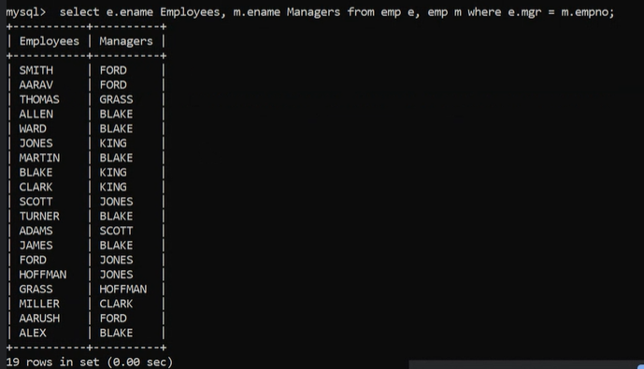

*.*

1. *Display details of all departments and the corresponding employees*

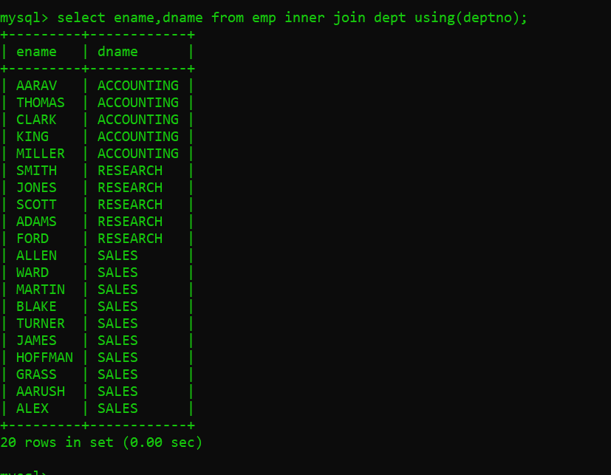

1. *Display all customer names with their order details (order number and ship date) for the orders shipped in 1987.*

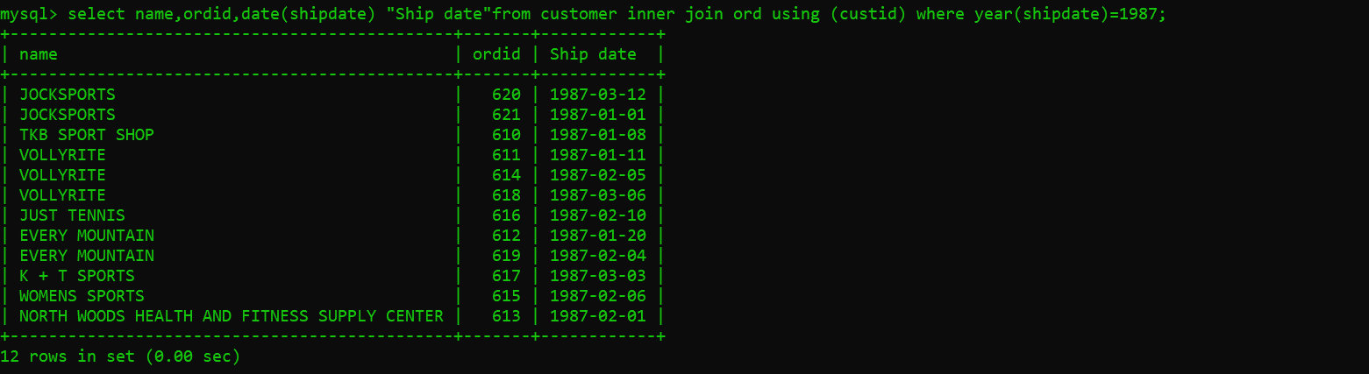

1. *Display salesman names and names of customers they are dealing with.*

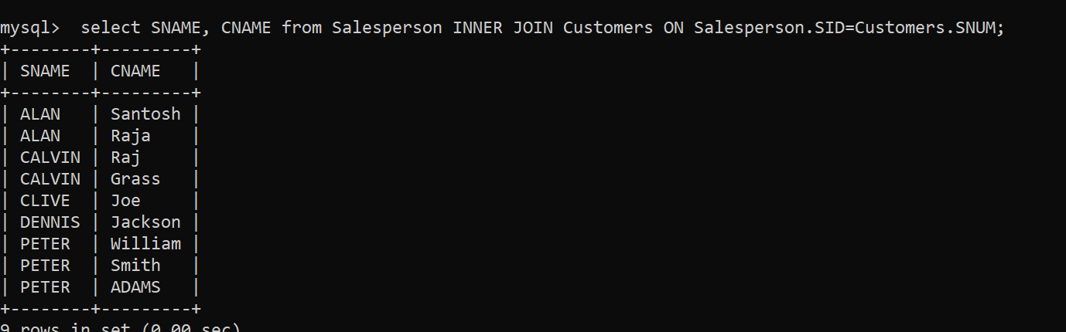

1. *Display salesman who did not earn commission, with customer names whom they are dealing with.*
2. *Display salesman names, salary, commission and their salary grades.*
3. *Display all Tennis products and their price details (standard and minimum price).*
4. *Display the products purchased by either JOCKSPORTS (customer number 100) or JUST TENNIS (customer number 103) or both of them.*
5. *Display the department name, and salary of any employee whose salary and commission matches both the salary and commission of any employee in DALLAS.*

Select Ename, DName, Sal from DEPT INNER JOIN EMP USING(DEPTNO) WHERE DEPT.LOC='DALLAS';

1. *List out the common jobs in Research and Accounting Departments in ascending order.*

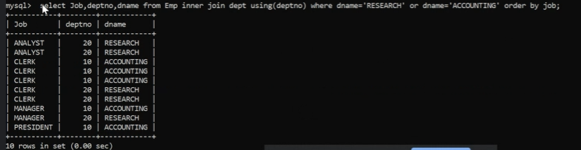

1. *Eployee placed on same date:*

SELECT A.ENAME,A.HIREDATE FROM EMP A, EMP B WHERE A.HIREDATE=B.HIREDATE AND A.EMPNO!=B.EMPNO;